Investment Newsletter – June 2023
Fight against inflation could be drawn out

Let’s start the monthly review by taking a look at the chart below, which reminds us that Australia’s inflation remains well above the target range of 2-3% desired by the government and the RBA.

Figure 1: Australia’s Inflation

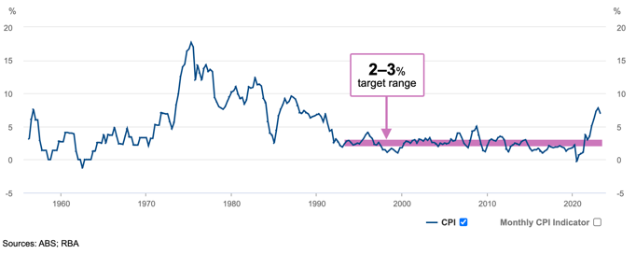

It definitely is a tall ask from the RBA to require consumers to voluntarily (or otherwise) bid farewell to a short-lived era of post pandemic spending and join the fight against inflation.

Ah, the glorious days of post-pandemic spending! The surge of spending brought forth waves of pure bliss and satisfaction as consumers raced to establish their home offices, tastefully furnished their newly acquired abodes, and revelled in the delightful anticipation of receiving regular packages from their online sprees.

It became a whole new way of life, brimming with excitement and joy. Regrettably for the consumers though, the Reserve Bank of Australia (RBA) is intent on forcing the consumers to bid adieu to this all-too-brief era of indulgence and get inflation down to 2-3%. This fight will be difficult and it could just be a little painful and drawn out for those borrowers and businesses who borrowed a tad bit too much.

The last reported inflation read in March 2023 came in at 7% p.a. Our suspicion, based on material evidence, is that the June quarter inflation number may come in slightly lower as consumers reluctantly pull back spending. However, we encourage all concerned to not let that softer June quarter outlook for inflation lure you into believing that inflation risk is over. It’s not!

Wage inflation is expected to pulse yet again from 1 July, with minimum wage rates in modern awards set to increase by 5.75% effective from 1 July 2023. Secondly, and more importantly, households in NSW, southeast Queensland, and South Australia will face electricity price rises of between 19.6% and 24.9% from July 1, while small businesses are facing increases of 14.7% to 28.9%, depending on their region. Needless to say, the cost of living and the cost of doing business are set to rise significantly from 1 July. But wait, there's more!

If inflation is the RBA's public enemy number one, and the source of inflation is squarely consumption or spending, then we need to sharpen our focus on the activities of spenders in the economy and find out if they are indeed heeding the RBA's directives or not.

In the next three charts below, we will illustrate to you that the three big spenders in the economy, i.e. consumers, businesses, and the government are just not slowing enough to bring inflation down even before the next round of inflationary pulses come through from 1 July. This fight of the RBA could take a while!

Figure 2: Retail spending growth is currently flat but needs to be negative to curb inflation
Needs to be negative
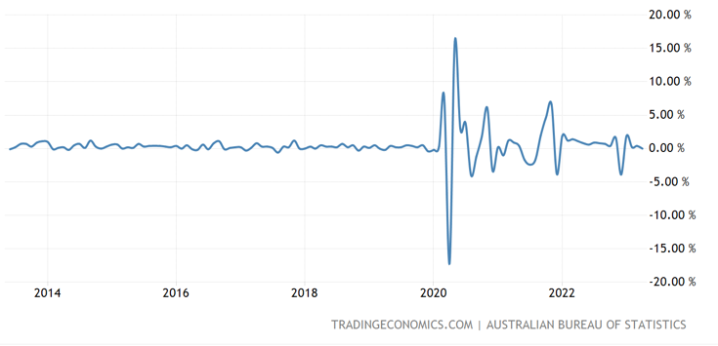
Source: Tradingeconomics.com

Figure 3: Business activity is growing and stoking inflation
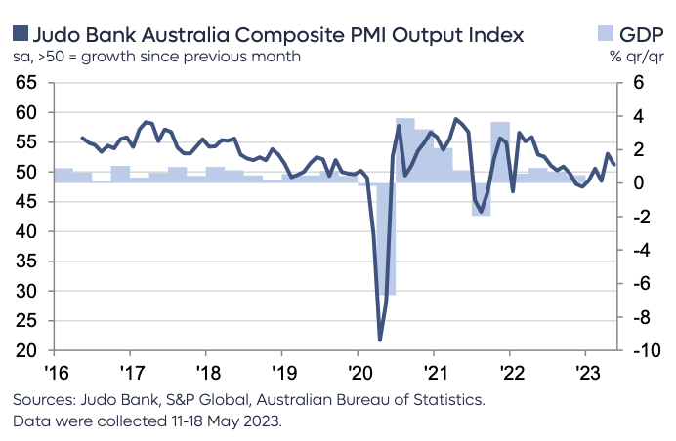
Needs to be negative
Figure 4: Government spending is growing and stoking inflation

Source: Australian Budget Papers 2023-24

The government expenditure, instead of pulling back, is actually growing strongly along with government debt.
In conclusion, expect further interest rate increases ahead punctuated by pauses. Expect earnings of companies to come under pressure in the coming months as they absorb higher interest payments on their debt and lower revenues from slowing consumption. And expect volatility in the share market. Investors can tactfully navigate these times by exercising just a little bit of caution, having flexibility in their portfolios with cash and liquid investments to nimbly shift into growth opportunities when the clouds of uncertainty are past their worst.
GLOBAL MARKETS OVERVIEW
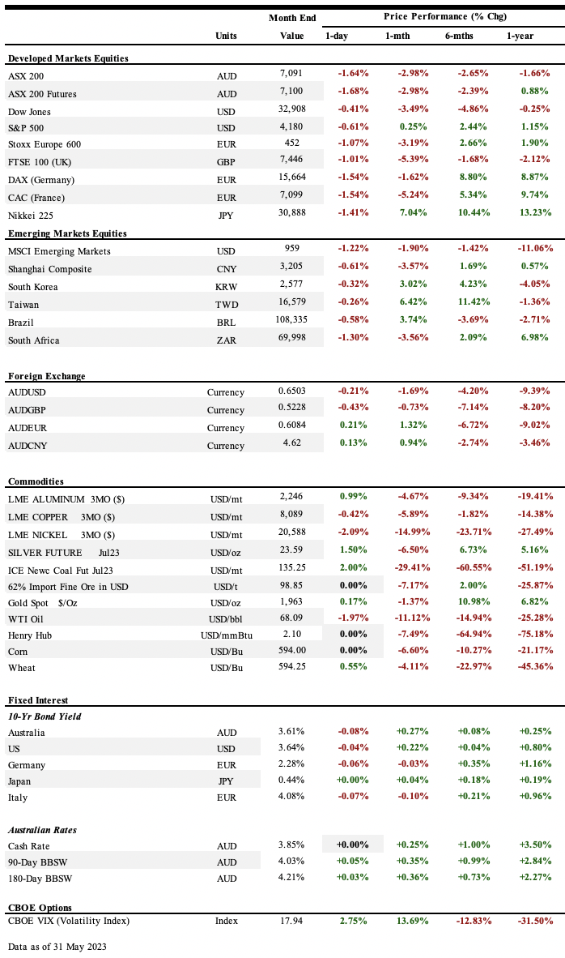

Economic News

• In Australia RBA increased its cash rate by +0.25% to 3.85%, the highest level since April 2012 with minutes from policy meeting revealing the Board agreed that further increases may still be required, but that this would depend on how the economy and inflation evolve.

• In US - Fed’s Beige Book revealed hiring and inflation cooled across the U.S., leading to Fed Chair Jerome Powell giving a clear signal he is inclined to pause interest-rate increases in June, saying that tighter credit conditions could mean the policy peak will be lower while announcing the stance of policy is restrictive and the economy faces uncertainty about the lagged effects of tightening so far, which saw swaps for July meeting showing a hike fully priced in after a pause in June.

Consumer confidence fell to a 6-month low in May despite 5-10-year inflation expectations retreating -0.1% to 3.1% and 1-year expectations declining -0.30% to 4.2%. Nonfarm payrolls increased 339k in May after an upwardly revised 294k advance in April, however, unemployment rate rose +0.3% to 3.7% while wage growth slowed to 4.3%. Business activity grew in May by the most in over a year, as robust demand for services saw services PMI surge to a 13-month high while the manufacturing index slipped back into contraction territory as orders shrank and output growth cooled.

• In China – The economy’s debt ratio reached a record high in 1Q23, with the macro leverage ratio, total debt as a percentage of GDP, soaring to 279.7%, up +7.70% q/q, the biggest jump in three years, with bank loans to companies surging as the nation reopened from Covid Zero. Economic recovery weakened in May with manufacturing activity contracting at a worse pace than in April and services expansion easing.

• In Europe - EU Commission downplayed fears of a recession by upgrading EU 2023 GDP growth outlook by +0.20% to +1% (euro area up to +1.1%) and 2024 to +1.7% (euro area up to +1.6%) while also boosting its inflation forecast for EU for 2023 to 6.7% (euro area up to 5.8%) and for 2024 to 3.1% (euro area up to 2.8%), citing "persisting core price pressures." Euro zone CPI eased to 6.1% y/y in May, its lowest level in more than a year, driven primarily by lower energy costs with core-CPI easing to 5.3% y/y. Euro-area consumer confidence rose less than anticipated in May and barely showed any improvement as consumer expectations for euro-zone inflation for the next 12-months increased to +5% and for three years ahead climbed to +2.9%.

• In Japan Economy expanded at a faster pace than expected in 1Q23 with GDP rising at an annualized pace of +1.6% q/q, with better-than-expected spending by consumers and businesses being the main driver behind growth with businesses increasing spending for a fourth straight quarter in 1Q23 with capex excluding software rising +2.7% q/q, while net trade dragged on the overall figures as shipments of cars and chip-making machinery fell.

GLobal Markets

• US markets. US markets were mixed, with the Dow Jones down -3.5% and S&P500 up +0.3%, as investor sentiment remained fragile amid months-long standoff over U.S. debt debt ceiling, with the default finally averted after President Joe Biden signed a bill in June that suspends the U.S. government's $31.4 trillion debt ceiling.

• Long-dated US treasury yields were higher, with the 2-Yr yield at 4.4% and 10-Yr yield at 3.64%.

• European markets European markets were lower with the Stoxx Europe 600 Index down -3.2%, German DAX down -1.6% and UK FTSE down -5.4%.

• Asian markets were higher, Asian markets were mostly higher over the month, with the Nikkei up +7.0%, as BOJ Governor Kazuo Ueda continued to strike a dovish tone, reiterating his view that Japan’s inflation is currently led by cost-push factors and is likely to slow toward autumn of this year, while announcing he intends to scrap the central bank’s yield curve control program once sustainable 2% inflation target comes into sight. KOSPI was up +3.0%. The Shanghai Composite declined -3.6%, as worries over weak economic data were exacerbated as XBB variant continued to fuel a resurgence in Covid cases across China with a Chinese senior health adviser predicting the variant to result in 40m infections a week by the end of May, before peaking at 65m in June.

• ASX performance. The ASX200 declined -3.0%.

• Commodities. Over the month, WTI oil price declined -11.1% to US$68.09/bbl

THE LONG READ

Lithium: The Essential element in the global clean energy transition
As the world seeks to reduce its carbon footprint and mitigate the impacts of climate change, the demand for renewable energy sources and electric vehicles has skyrocketed. At the heart of this transition lies lithium, a soft, silvery-white metal that is essential for the production of lithium-ion batteries, which power everything from smartphones to electric cars.
Lithium plays a crucial role in reducing greenhouse gas emissions
The transition to clean energy and transportation is essential for reducing greenhouse gas emissions and mitigating the impacts of climate change. Lithium-ion batteries are a key component of this transition to clean energy. To state the obvious, transport vehicles can use the stored energy in lithium batteries to operate instead of burning petrol that causes CO2 emissions. Secondly, the stored energy in the lithium batteries themselves has to come from somewhere, and that somewhere can be solar panels installed on your roof top during the day to recharge your lithium batteries in your electric vehicle or battery for the house.
In the future, there will also be grid-level, large lithium batteries installed next to solar and wind farms that charge these batteries to supply renewable energy to the electricity grid at night. The chart below from Australian government’s latest budget papers speaks for itself. What the graph is telling us in the purple and black bars is that both solar energy and lithium battery storage in Australia is set to grow significantly in the years ahead. Moreover, it is safe to infer similar growth for other major economies.
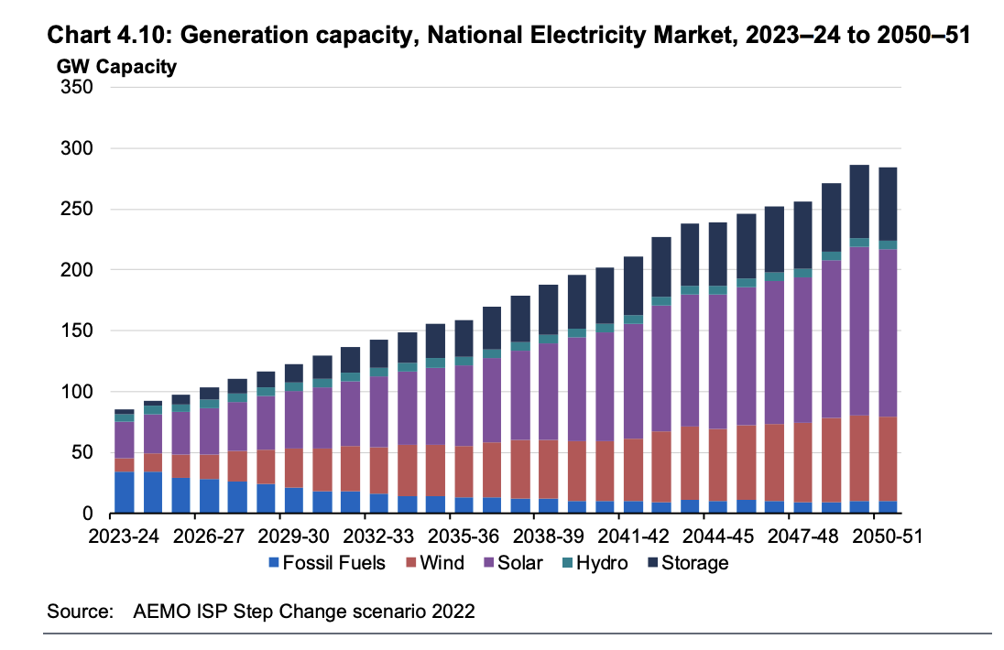

The International Energy Agency estimates that electric vehicles could save up to 1.5 million barrels of oil per day by 2030, while renewable energy sources could provide up to 70% of the world's electricity by 2050. These figures demonstrate the potential for lithium-ion batteries to play a crucial role in reducing greenhouse gas emissions and mitigating the impacts of climate change.
Lithium is essential for the production of lithium-ion batteries
The race for battery dominance and the new energy revolution is well underway, with countries around the world are vying for control over this critical resource.
Lithium-ion batteries are widely used in portable electronics, electric vehicles, and grid-scale energy storage systems. These batteries are lightweight, rechargeable, and have a high energy density compared to other types of batteries. High energy density is an important consideration because it tells us how much energy can be stored in a given amount of space or weight. This is particularly important for batteries, as they need to store as much energy as possible in a small and lightweight package. The higher the energy density of a battery, the more energy it can store per unit of weight or volume, which means that it can power devices for longer periods of time or allow electric vehicles to travel further on a single charge.
However, the production of electric batteries require large amounts of lithium. The average electric vehicle battery requires between 10-15 kilograms (22-33 pounds) of lithium carbonate equivalent (LCE), while grid-scale storage systems can require hundreds or even thousands of tonnes.
Consequently, the demand for lithium is experiencing a

significant increase. This is particularly visible in the growth of the lithium-ion battery market, which is projected to grow over +30% p.a. from 2022 to 2030, according to McKinsey & Co.
As of 2023, there are approximately 2,531,206 electric vehicles in the United States​, according to Statista (a data firm). The total number of vehicles in the U.S. is around 286 million​. Thus, the percentage of electric vehicles in the U.S. in 2023 is about 0.88%.
The growth forecast for electric vehicles in the U.S. suggests that they will account for 32% of the market in 2030 and 45% in 2035​. This represents compound annual growth rate of 32% p.a. of electric vehicles and Lithium batteries in the US alone.
This surge in demand has led to a flurry of activity in the global lithium market as countries seek to secure their supply chains.

The global race for battery dominance is intensifying
As demand for lithium-ion batteries continues to grow, countries around the world are competing for control over this critical resource. Lithium reserves are concentrated in a handful of countries, including Australia, Chile, Argentina, and China. This concentration of resources has led to intense competition among these countries as they seek to secure their supply chains and gain a competitive advantage in the global lithium market.
The global race for battery dominance is evident in the significant investments being made by governments and private companies around the world. China has invested heavily in lithium mining and processing facilities, while Australia has become a major exporter of lithium concentrate. In addition, companies such as Tesla are investing billions of dollars in new battery factories and research and development initiatives aimed at improving battery performance and reducing costs.
Lithium resources occur in two distinct categories: lithium minerals, largely from the mineral spodumene (Li₂O.Al₂O₃.4SiO₂), and salts, largely from lithium-rich brines in salt lakes. All of Australia’s current resources and production are from lithium minerals, chiefly spodumene, while lithium brine is produced predominantly in Chile, followed by Argentina, China and the USA.
In Australia, we have liked Allkem (ASX: AKE) for a number of years. AKE is currently proposing to merge with Livent Ltd, a smaller US based competitor. If the merger is accepted by the shareholders then Allkem will become the third largest global supplier of lithium chemicals. Livent will add considerably to Allkem’s processing capability and specifically what we like about Livent is its capabilities in Direct Lithium Extraction (DLE).
Direct Lithium Extraction (DLE) capability could possibly boost the availability of lithium derived from brine, potentially close to doubling both the production and yield of lithium (increasing recoveries from 40-60% to 70-90%). This enhancement could lead to better profitability for Allkem. Additionally, DLE offers environmental and social governance (ESG) benefits to Allkem, such as potentially a more than 20-fold reduction in land usage due to the elimination of evaporation ponds for brine, improved water usage metrics through potential brine reinjection. Production cost economics should also improve.
Alternatively, investors can play Lithium thematic through a broad-based ETF, Lithium & Battery Tech ETF (ASX: LIT). LIT invests in companies throughout the lithium cycle, including mining, refinement and battery production, cutting across traditional sector and geographic definitions.
In conclusion, the global transition to clean energy and transportation is one of the most pressing challenges facing our planet today. Lithium plays a crucial role in this transition as it is essential for the production of lithium-ion batteries that power electric vehicles and renewable energy sources.

For enquiries:

• Micksteffan@ifswa.com.au
• Phone: 0466414321
• Write to: Independent Advisers WA, 58 Hillview Drive, Drummond Cove, WA 6532

Goods

