Investment Newsletter – July 2023
Low growth and inflation for another two years

THE NEW RBA CHIEF WANTS TO HAVE HER CAKE AND EAT IT TOO
We can’t write a monthly letter and not mention some latest revelation on inflation. The outgoing governor of the Reserve Bank of Australia (RBA), Phillip Lowe, mentioned in a recent interview that the RBA is working towards reducing inflation from the current rate of 5.6% per year to 3% by mid-2025. This target is set two years from now, although you are justified in your reluctance to fully trust the RBA's forecast due to its poor track record
The interviewer pointed out that the RBA chief has been more cautious in raising interest rates compared to other countries. In response, the governor explained that the slower pace of interest rate increases was a deliberate choice to protect the gains in employment achieved in recent years. It's worth noting here that Philip Lowe is expected to be succeeded by Michelle Bullock, who has been nominated from within the bank and will assume the role of governor in September.

Michelle Bullock delivered a speech in June emphasizing the significance of maintaining a delicate balance between reducing inflation through interest rate hikes and fulfilling the mandate of ensuring full employment. From her remarks, it is evident that she is willing to tolerate inflation above the target for a longer period, as long as inflation shows a gradual downward trend she will be happy it appears. Both Bullock and the departing governor seem to be accepting the possibility of higher inflation persisting for an extended period while prioritizing robust employment. We endorse this sensible approach.
The other important signal coming from the RBA is that they expect the outlook for the Australian economic growth to be subdued over the next couple of years.
All that means is that higher income return from the defensives part of your portfolio should start to feature more prominently and will stay that way for a while. Works for us!
Higher interest rates and risk to private asset values
While our clients enjoy the advantage of predominantly investing in publicly listed and liquid assets with daily pricing (meaning your investment returns are real and bankable), the same cannot be said for large institutional funds and industry super funds. These funds often allocate up to 50% of their portfolios to private assets, which lack daily pricing and rely on crude and overly optimistic book valuations. This optimistic approach artificially inflates investment returns during market downturns.
As interest rates have continued to rise, publicly listed property & infrastructure assets on the ASX and other bourses have already undergone a significant repricing, dropping by 25% on average. However, similar assets held as private assets within large public super fund portfolios are only beginning to face downward adjustments.
Since 2021, these public super funds have been hoping (praying) that higher inflation will be brought back to target range of 2-3% p.a. by central banks relatively quickly and interest rates will not remain high for long and so there will not be a need for them to make negative adjustment to private asset values. However, it is now expected that higher inflation and interest rates will persist for the next few years, or possibly even longer. This is concerning because it will have a negative effect on the values of private assets.
As you can glean from the evolving RBA narrative mentioned earlier in this read that it too expects higher inflation to mid 2025. Similar projections on inflation have started to echo from the US Federal Reserve and European central bank. This evolving narrative on inflation carries with it the inference that interest rates will also remain higher for longer. This translates to valuations of private assets to come under pressure. Trustees of public super funds will come under pressure from APRA (the regulator) to start getting real about the inflated book values of their investment portfolios.
Investing in private assets comes with inherent risks, particularly due to valuation write-downs that occur with a lag effect. Private assets offer less transparency and rely on subjective valuations compared to publicly traded assets. Initial valuations may be overly optimistic, leading to a distorted representation of true value of public super fund portfolios.
The lag effect refers to the delay in adjusting valuations to reflect an asset's actual worth. This delay can result in investors holding overvalued assets, which eventually leads to reduced returns when valuation adjustments are finally made.
Columbia University research predicts a long-lasting crisis for New York offices, projecting a 44% loss in pre-pandemic value by 2029 due to the impact of remote work, high vacancy rates, costly repositioning of assets to residential due to funding now at high interest rates.
It is for these reasons investors should be cautious in investing in public super funds and unlisted private assets (property, equity, and debt). Stick to listed markets or if private assets are to be used in portfolios they should be limited and/or have a sound investment thesis justifying their use in portfolios.
GLOBAL MARKETS OVERVIEW
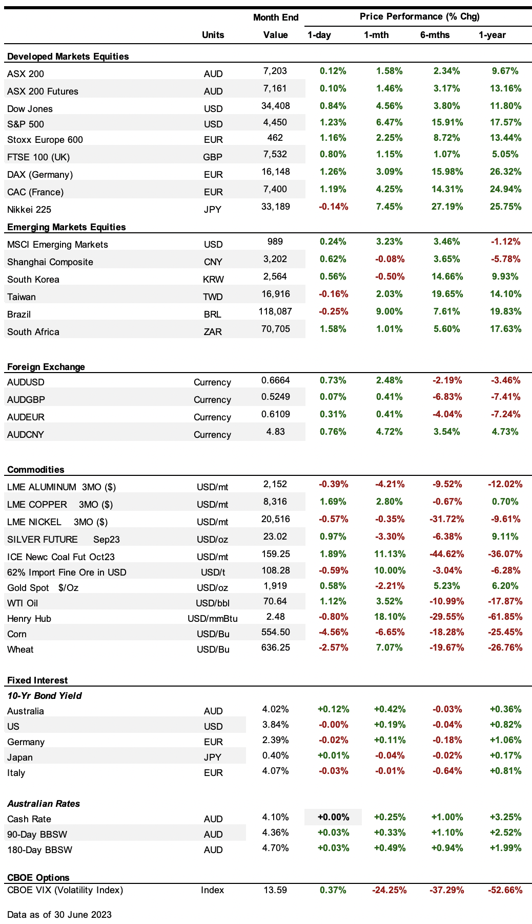

Economic News

• In Australia, in an unexpected move, the Reserve Bank of Australia (RBA) raised its key interest rate by 25 basis points (0.25%) to 4.1%, marking the highest level seen since April 2012. This latest increase adds to the cumulative tightening of 400 basis points (4%) implemented since May 2022. The RBA remains open to the possibility of further rate hikes, expressing concerns that tighter policy is necessary to ensure a confident return of inflation to the target level by mid-2025.

The economy experienced a slower-than-expected growth in the first quarter of 2023, with the gross domestic product (GDP) expanding by 0.2% compared to the previous quarter and 2.3% year-on-year. This represents the weakest three-month expansion since September 2021.

Consumer confidence showed a slight improvement in June, rising by 0.2% month-on-month. However, it remained at levels considered close to recession lows, indicating a somewhat stabilized but still cautious sentiment among consumers.

• The US markets showed strength, with the Dow Jones rising by 4.6% and the S&P 500 up by 6.5%. The Federal Reserve upgraded its 2023 US GDP forecasts by 60 basis points (0.60%), now projecting a growth rate of 1%. Additionally, the Fed forecasts GDP growth of 1.1% for 2024 and 1.8% for 2025. On the inflation front, the Fed lowered its 2023 Personal Consumption Expenditures (PCE) inflation rate forecast by 10 basis points (0.10%) to 3.2%, while increasing projections for core inflation.

Long-dated US treasury yields experienced an increase, with the 2-year yield reaching 4.898% and the 10-year yield at 3.84%. The Federal Reserve kept the benchmark interest rate unchanged at 5-5.25%. However, the Fed indicated that borrowing costs are expected to rise to 5.6% by the end of the year, a 50 basis point (0.50%) increase from previous projections. Fed Chair Jerome Powell emphasized that it would be a "couple of years" before the Fed considers cutting rates and stated that two more rate hikes this year are a reasonable expectation. This led to the market fully pricing in another 25 basis point (0.25%) increase at the September meeting, with the possibility of a further increase in November, and no rate cuts expected in 2023.

• In China – The economy faced further challenges in June as manufacturing activity contracted for the third consecutive month. Additionally, home sales took a sharp decline, with the value of new home sales by the 100 largest real estate developers falling by 28.1% year-on-year to 526.74 billion yuan.

• Asian markets showed a mixed performance in recent trading sessions. The Shanghai Composite experienced a modest decline of 0.1%. This decrease came as Chinese banks made a relatively small reduction in the mortgage reference rate, with both the 1-year and 5-year LPR (Loan Prime Rate) being lowered by 10 basis points (0.10%) to 3.55% and 4.2% respectively. Additionally, concerns about the weakening economy persisted as China's stimulus rollout faced delays, with the State Council refraining from releasing specific proposals and stating that the government is studying new measures to be implemented in a timely manner. Despite these concerns, the People's Bank of China (PBOC) reduced the seven-day reverse repurchase rate by 10 basis points to 1.9%, marking the first rate cut since August 2022.

Meanwhile, the KOSPI index in South Korea declined by 0.5% as BOK Governor Rhee Chang-yong expressed concerns about growing risks in the financial sector, citing an increase in delinquencies of real estate loans. On the other hand, the Nikkei index in Japan witnessed a gain of 7.5% during the same period.

• The European Central Bank (ECB) has increased interest rates by 25 basis points (0.25%) to reach 3.5%, the highest level seen in more than two decades. ECB President Christine Lagarde has indicated that another rate hike in July is highly likely. The bank's latest quarterly projections suggest that inflation will moderate at a slower pace than previously expected, reaching 2.2% in 2025.

Despite experiencing a mild recession in the first quarter of 2023, with a 0.1% quarter-on-quarter contraction (up 1% year-on-year), the euro area saw a decline in inflation during June. Consumer Price Index (CPI) rose by 5.5% year-on-year, the lowest level since before the war in Ukraine began. However, core CPI, which excludes volatile components, re-accelerated, rising by 5.4% year-on-year, primarily driven by an increase in the cost of services.

Economic momentum in the euro area slowed significantly in June, with manufacturing remaining the primary weak spot.

THE LONG READ

Demographic Destiny: A Game-Changer for Smart Investors
The global phenomenon of aging populations poses significant challenges to countries around the world. The burden of an aging demographic has far-reaching consequences on various aspects of society, including supply of labour and inflation, lower economic growth, fiscal instability of government budgets leading to forever more government borrowing and risks to their credit ratings, and weaker geopolitical influence. These consequences need to considered when allocating capital to different markets in investment portfolios.
In this article, I will present key arguments surrounding demographic challenges ahead that appear to weigh in favour of United States, Australia, and India compared to Germany, Japan, and China which look decisively weaker. Let’s explore key indicators such as demographic profiles, labour market dynamics, economic resilience, and geopolitical influence to see why I have arrived at above conclusion.
Demographic Profiles
Understanding the age structure and population trends of different countries is crucial in evaluating the burden of aging demographics. The great industrial powers of Germany, Japan, and China are currently facing significant demographic challenges characterized by low birth rates, declining populations, and rapidly aging societies. China’s population is both ageing and decreasing with projections of a decrease by 48 million, or around 2.7%, between 2019 and 2050. Additionally, according to the United Nations World Population Prospects, these countries are projected to have older populations with median ages exceeding 50 by 2050.
In contrast, the United States, Australia, and India display more favourable demographic profiles. While they also face the challenges of aging populations, their demographic advantages are notable. The United States and Australia have relatively higher birth rates, 12.0 per 1,000 and 12.1 per 1,000 respectively, and younger populations compared to Germany (9.3), Japan (7.0), and China (10.6). Similarly, India has a large and growing population at 17.0 births per 1,000, with a median age projected to be only 38 by 2050.
These demographic advantages provide the US, Australia, and India with larger potential workforces and a greater capacity for economic productivity.
Labour Market Dynamics
The labour market dynamics play a crucial role in determining a country's ability to address the challenges of an aging demographic. Shrinking workforces and labour shortages can hinder economic growth and productivity. However, the United States, Australia, and India, with their younger populations, are better positioned to sustain labour market stability and mitigate the negative effects of demographic shifts.
According to the Bureau of Labour Statistics, the United States has maintained a relatively high labour force participation rate compared to Germany, Japan, and China. Australia has also demonstrated a higher labour force participation rate, bolstered by robust immigration policies. India's growing population provides a significant workforce potential.
These factors indicate a larger proportion of the population actively contributing to the labour market, thus supporting economic output and mitigating potential labour shortages.
Specifically, when there are more people who can work, it means there are more hands and minds to do the job. This can make the economy stronger because there are more people available to produce goods and offer services. Having a bigger potential workforce also means that there are more people who can learn new things and come up with fresh ideas. This can lead to innovation and help businesses grow and create new products and services.
So, in the United States, Australia, and India, having a large and relatively younger potential workforce can help their economies become stronger and more productive. It's like having a big team of people working together to make things and make the country better.
Economic Resilience
The economic resilience of a country in the face of aging demographics is critical to managing the associated burdens. Germany, Japan, and China confront the challenge of sustaining economic growth and managing public finances amidst rising healthcare and pension costs. These countries may experience reduced economic growth rates and increased fiscal pressure, which can strain government budgets and hinder public investments.
In contrast, the United States, Australia, and India exhibit greater economic resilience. According to the International Monetary Fund (IMF), these countries have projected economic growth rates that outperform many other advanced economies. The IMF also highlights the positive correlation between demographic factors such as labour force growth and economic performance. The US and Australia, with their younger populations and robust labour markets, have the potential for sustained growth. India, with its large and dynamic workforce, offers significant economic opportunities.
Geopolitical Influence
Aging demographics can also influence a country's geopolitical influence and global standing. Germany, Japan, and China, despite being significant global players, face the challenge of diminished influence due to potential economic and societal pressures associated with aging populations. Older populations tend to have different priorities and interests than younger generations. They may focus more on social welfare and healthcare, which can lead to increased government spending in these areas. This shift in focus can divert resources and attention away from other areas crucial for geopolitical influence, such as defence, foreign policy, and diplomatic initiatives.
The United States, Australia, and India, on the other hand, are better positioned to maintain their geopolitical influence due to their favorable demographic profiles, economic resilience, and relatively stronger labour markets.
Therefore, the burden of aging demographics poses complex challenges for countries worldwide. While Germany, Japan, and China face significant obstacles associated with declining populations and aging societies, the United States, Australia, and India possess demographic advantages that position them more favourably. These countries have relatively younger populations, more robust labour markets, economic resilience, and potential for sustained growth. While no country is exempt from the consequences of aging populations, the United States, Australia, and India demonstrate a comparative advantage in navigating the burden of demographic changes, positioning themselves for greater stability and influence in an aging world. Those investors taking a long-term view of the markets, need to consider investing in countries that have relatively more attractive demographic profile rather than getting stuck in countries where the demographic weaknesses are set to get worse in the years ahead.

For enquiries:
- Email
- Phone (02) xxxxx (within Australia), or
- Write to:
xxxxx

IMPORTANT DISCLAIMER – Please read carefully
This newsletter is copyright and is for the clients of xxxxxx. The reproduction of any part of the letter, for any purpose, is not permitted. The view expressed in the newsletter are for general information purposes only and are not meant to be taken as personal financial advice.
Goods

