**Investment Newsletter – November 2024**

**President Trump 2.0…**

Welcome to the November 2024 letter.

**Trump 2.0 – Trump euphoria.** Since the election of U.S. President Donald Trump for a second term, investors have been busy deliberating what it means for the global economy and financial markets. So far markets have reacted very positively to President Trump’s decisive win against Kamala Haris, with Republicans gaining control of both houses. President Trump campaigned hard on policies aimed at boosting U.S. growth, including proposed tax cuts, illegal immigration, imposing tariffs and deregulation, which have fuelled the so-called "Trump trade" in recent weeks. Further, recently published data in the U.S. also revealed consumer confidence increased in November to the highest level in more than a year with a gauge of present conditions increasing to an eight-month high, measure of expectations for the next six months edging to an almost three-year high and inflation expectations over the coming year dropping to the lowest level since March 2020. However, we suspect once the new President’s inauguration is over in January 2025, the “Trump trade” may fade as the reality of some of President Trump’s election policies sets in.

**Trump 2.0 - unintended consequences.** It’s important to note there remains a few question marks over just how President Trump’s key policies will play out in the real world. A strong U.S. economy relative to the rest of the world (which has its challenges including China and Europe), will drive the already elevated U.S. dollar higher. Further, U.S. Treasury yields have been rising in anticipation of President Trump’s win since mid-September, as investors price in stronger U.S. domestic growth and higher inflation in the months ahead. Both higher Treasury yields (that is, cost of capital) and U.S. dollar is a tax on growth, especially for the rest of the world. Recent global data releases have broadly disappointed expectations, primarily due to weaker-than-anticipated survey data from Europe. This has raised questions about the

sustainability of a bullish outlook for global growth. Add to this Trump’s proposed tariffs, which could also cost the U.S. consumers (as higher costs on imports is passed onto consumers) and not just the countries subject to these tariffs.

**Trump 2.0 – some sobering statistics.** It is worth highlighting a few statistics which brings home the challenge ahead for the incoming Trump administration. Since President Trump was last in the Oval Office, the total U.S. government has significantly increased.

**Figure 1: Total U.S. government debt (US$ trillion)**

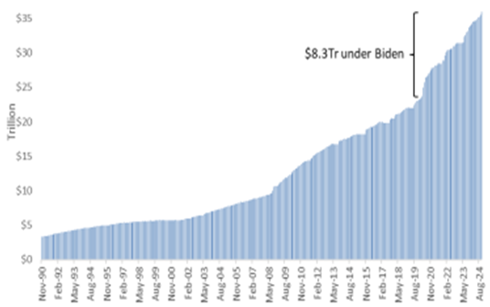  
Source: BT Report, U.S. Treasury Dept Banyantree

In fact, under President Joe Biden U.S debt has increased by US$8.3 trillion. Markets are already of the view the U.S. is on an unsustainable debt path. Hence President Trump must walk the tight rope of reining in spending whilst not stalling economic growth. U.S. Treasury is expected to refinance around US$10 trillion of debt between now and the end of 2025. With short-term rates still around 4.5%, the weighted fixed cost of that debt - which is currently around 2.6% - will increase dramatically in the coming years.

**Figure 2: U.S. Federal government debt service costs (US$bn)**

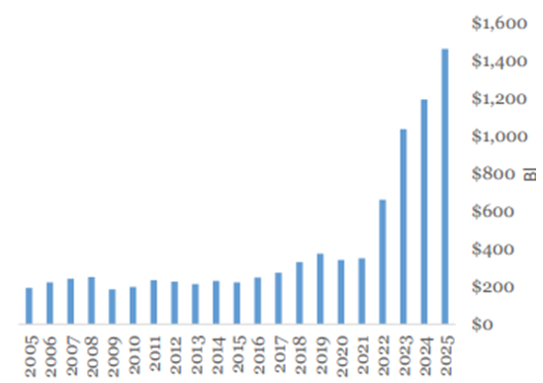  
Source: BT Report, Banyantree

Further, as it stands right now, President Trump’s fiscal policies could in fact exacerbate the current U.S. debt problem. The non-partisan Committee for a Responsible Federal Budget (CRFB) provided a summary of the budgetary impact of Trump’s policy proposals. It showed the total impact from President Trump’s fiscal policies would be a net deficit of US$7.75 trillion (the central case).

**Figure 3: Summary of Trump Plan (Savings/costs) (US$bn)**

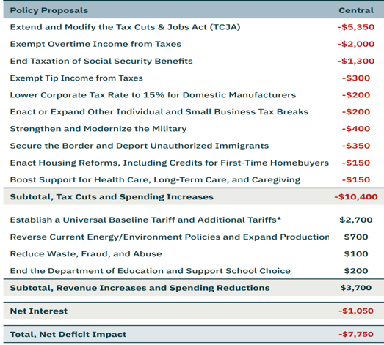  
Source: BCA, Banyantree,

It’s important to appreciate, whether we like it or not, U.S. fiscal and monetary policies are a key driver of global markets and economic growth, including asset prices in Australia. Understanding the direction of U.S Treasury yields, U.S. dollar (given it is the global reserve currency) and global liquidity goes a long way in making the right asset allocation calls in client portfolios, in our view.

**GLOBAL MARKETS OVERVIEW**



Economic News

**• In Australia**. RBA held its key interest rate at a 13-year high of 4.35% and restated that it isn’t “ruling anything in or out” on policy given the “high level of uncertainty” on the international front and high underlying inflation, as the bank downgraded forecasts for economic growth by -20bps to +1.5% by year’s end and -30bps to +2.3% for June 2025, while also downgrading underlying inflation outlook for 2024 by -10bps to 3.4% and forecasting it to reach the top of the 2-3% target band in mid-2025 before touching 2.8% by the end of that year. Consumer confidence jumped in October to a 2.5 year high as households now reckon the RBA has concluded its campaign of interest-rate increases amid signs of a moderation in inflation with 12-month ahead consumer inflation expectations declining -40bps MoM to 4%, the lowest in 3-years. House prices advanced at a slower pace than prior month in October, increasing +0.2% MoM, with -0.1% MoM decline in Sydney, the first decline since January 2023, and -0.2% MoM decline in Melbourne, more than offset by +1.4% growth in Perth.

• In U.S. The Fed cut interest rates by -25bps to 4.5-4.75%, while announcing policy is still restrictive even after the cut and recent indicators suggest that economic growth remain resilient with policymakers no longer including a line about achieving “greater confidence” that inflation is moving sustainably toward 2%, though noting inflation has “made progress” toward the central bank’s goal. Consumer confidence increased in October by the most since March 2021 to the highest level since the start of the year, with a measure of expectations for the next 6-months rising to the highest since December 2021.

• In China. Chinese banks cut their benchmark lending rates after easing by the central bank at the end of September, decreasing both the 1-year and 5-year LPR by -25bps to 3.10% and 3.60%, respectively. Economic expansion slowed in 3Q24 with GDP increasing +4.6% y/y, the slowest pace since March 2023, bringing YTD growth to +4.8%, the lower end of government’s annual growth goal. Factory activity unexpectedly expanded in October after five months of contraction with official manufacturing PMI rising more than expected and non-manufacturing PMI showing activity in construction and services expanded after staying little changed the previous month. Export growth surged in October to the fastest since July 2022, rising +12.7% y/y to $309bn which combined with -2.3% y/y decline in imports to $213bn saw the trade surplus climb to the third highest on record.

• In Europe. ECB lowered interest rates for the third time this year, cutting the key deposit rate by 25bps to 3.25% and announced the process of taming prices should be complete “in the course of next year,” tweaking its previous language for that landmark to only be reached in 2H25, with President Christine Lagarde reiterating that the economy should recover in time, as interest rates decline and shoppers spend more, but said risks to growth remain tilted to the downside, however, a recession isn’t likely. Euro area's economy expanded more strongly than expected in 3Q24 with GDP growth of +0.4%, as momentum in France accelerated and stayed strong in both Spain and Germany, partially offset by Italy, where output was unexpectedly flat, driven by a negative contribution from net trade. Eurozone consumer confidence improved MoM in October to its highest since Russia invaded Ukraine in early 2022, with falling inflation fattening wallets as pay rises outstrip price rises.

• In UK. BOE cut borrowing costs for the second time this year by -25bps to 4.75%, but stopped short of signalling faster easing, warning that last week’s budget could drive up inflation by as much as +50bps to peak at 2.8% in 3Q25 before slowing below the goal to 1.8% in the course of 2027. Chancellor of the Exchequer Rachel Reeves unveiled £40bn of tax rises, the most in decades, entailing to capital gains tax and employers’ national insurance contributions, while also paving the way for higher borrowing for investment to speed up an economy hit by the 2007-09 financial crisis, Brexit, Covid-19 and soaring energy prices.

• India. RBI held its benchmark repurchase rate at 6.50% but opted to change the policy stance to neutral, signalling the next likely move may be a cut as it retained its growth and inflation projections for the fiscal year through March 2025 at 7.2% and 4.5%, respectively, with Governor Shaktikanta Das announcing food costs, which make up about half of the consumer price basket, will likely ease in coming months, improving the outlook for inflation.

• Japan. BOJ kept its benchmark interest rate unchanged at 0.25%, however, Governor Kazuo Ueda indicated the bank remains on track for more rate hikes given upside risk to inflation for fiscal 2025. The bank maintained its 2024 and 2026 GDP growth outlook of +0.6% and +1%, respectively, however, upgraded 2025 outlook by +10bps to +1%.

THE LONG READ

Equities in 2025…

Will global markets continue to rally in 2025? Below we provide some thoughts on how things could play out.

**Easing monetary policy cycle should benefit non-U.S. stocks.** The recently published December edition of the Blue Chip Financial Forecasts survey highlighted that there is an expectation that the U.S. election results will now see a slower pace of Federal Fund Rate (FFR) cuts going forward. However, forecasters are still fully expecting a 0.25% cut at the December FOMC meeting but for 2025, consensus now looks for 1.03% of cuts versus 1.26% of cuts in the November survey. On the other hand, forecasters don’t expect the U.S. election result to have an impact on Europe’s policy path and expect further cuts from the European Central Bank (ECB) in the year ahead. The consensus specifically now looks for 1.14% of ECB cuts over the next 12 months and 1.0% from the Bank of England (BoE). The implication for global equity markets is that investors may start to look at attractive valuations outside of the U.S. as fundamentals and earnings growth outlook improve as global central banks ease monetary policy in 2025. Keep in mind, equity markets outside of the U.S. tend to be more cyclical, hence an easing cycle should benefit them more in theory.

**Figure 1: Expected changes in policy rates over the next 12 months**

Source: Haver Analytics, Banyantree

**However, U.S. tariffs are likely to be more negative for non-U.S. stocks.** President Trump’s first tariffs resulted in margins for companies globally, but interestingly the shares of those with the highest revenue exposure to the U.S. did end up outperforming. Thus, suggesting that management teams of these firms managed to navigate the tariff impacts. However, Trump 2.0's tariffs could be a harder proposition because most global companies’ exposure to the U.S. has increased since Trump 1.0 imposed tariffs, particularly in health care. Further, what the Fed does will also matter. The 200 largest companies outside of the U.S. (excluding financials and utilities) that disclose geographic exposure earned 27.4% of their revenue from the U.S. on average in 2023 (median 26.3%), up from 24.9% (22.2%) in 2017. Health care is most reliant, with U.S. revenue increasing to 38.8% from 31.1%. Packaged medications and vaccines are one of the most-imported goods into the U.S., just behind petroleum and cars/auto parts

**But markets will get over tariffs, as they did in 2019.** Though tariffs may increase uncertainty in 2025, we note the experience of 2018 and 2019 may offer some hope. Most global equity markets suffered in the second half of 2018, in part likely due to declining margin sentiment amid the tariff surprise that year, and then bounced back aggressively in 2019 even though many of the tariffs remained. As we have noted earlier, monetary policy will again be important, with global central banks largely in an easing cycle. U.S. Fed easing usually benefits non-U.S. equities via improvement in sentiment (that is, increases risk taking/tolerance) and could offset some of the concerns caused by tariffs. In 2018, the U.S. Fed was tightening while central banks in China and Europe held steady.

**AI may take a back seat.** According to analysts’ expectations, AI’s impact to equity market earnings momentum may have peaked in 2024, and ex-AI growth could accelerate in the year ahead. While artificial intelligence stocks dominated global equity market returns during the first half of 2024, the group has yet to fully recover to its mid-July highs, giving other global equities a chance to play catch up. From the start of the year through the market's high on July 12, AI stocks on average returned 22.9% while the rest trailed at just 4.6%. Since then, AI companies have fallen on average 0.3%, and 49 of the 81 AI stocks globally (60%) are still below their record-high levels set earlier in the year. The rest of the market has continued to gain at a steady pace, returning 6.3% on average, and continues to press to new highs. AI's giant lead at the start of the year still puts the group well ahead for the year, returning 22.1%, with the rest up just 11.8%

**Inflation remains a risk for equities.** Equity markets may be caught off guard if inflation accelerates in 2025 due to better-than-expected economic growth. The correlation between global equities and bonds has once again turned to negative territory for the first time since early 2020. This suggests inflation is no longer a key concern for investors. Historically, the two asset classes' returns are the most in sync (i.e., correlations are most positive) when global inflation (measured by the BI Global Inflation Index) is higher than 3%. Global inflation dropped below 3% in May for the first time since March 2021. U.S., European (excluding the UK) and Canadian equity and bond returns were negatively correlated over the last 26 weeks, while all other major markets maintained positive, but have declining correlations.

**Emerging markets uncertainty.** Stocks in emerging Asia may continue to find it tough going in 2025. Asia continues to struggle, with decelerating earnings growth and slowing manufacturing activity. While the stimulus announcements in China should be positive, it may not be enough to support a sustained equity markets rally in EM.

For enquiries:

Email: **micksteffan@ifswa.com.au**

* Phone **0466414321**
* Address: **58 Hillview Drive Drummond Cove, WA 6532**

**IMPORTANT DISCLAIMER – Please read carefully.**

This newsletter is copyright and is for the clients of Independent Advisers WA. The reproduction of any part of the letter, for any purpose, is not permitted. The view expressed in the newsletter are for general information purposes only and are not meant to be taken as personal financial advice.

Goods