Investment Newsletter – August 2023
The slowdown is becoming palpable

We’d like to begin this month's letter with a general reflection on the state of the economy. The comprehensive economic data released globally in major advanced economies over the past four weeks indicates a slowdown or contraction in business activity and consumption.
# Economic activity is slowing, everywhere …
One way to gauge the pulse of the economy is by talking to businesses and asking how they are faring. We can get a good sense of whether businesses are satisfied with their current sales and trading activity, and whether they are battening down the hatches in anticipation of a slowdown. These surveys, formally known as the Purchasing Managers Index (PMI), can also serve as leading indicators for future trends in unemployment rate, inflation, business profitability, dividends, and share prices.
We specifically look for a general trend in these survey readings over successive months to confirm our assumptions of the near-term direction of the economy.
For consumption driven economies of Australia, US, and Europe the activity indicator to watch is Services PMI which surveys a range of services businesses. A reading below 50 indicates contraction of these businesses and profitability.
In July, the services PMI in Australia declined to 48.2 points. While the US reported a positive figure at 52 points, it has shown a clear declining trend over the past three months. In Europe, the PMI has also been consistently declining, currently standing at 50 points. On the other hand, in China, the Manufacturing PMI is of greater significance due to its export-oriented industrial economy. This PMI has also consistently fallen over the past three months, now registering at 49 points.
Looking at these surveys from various countries, and should these downward trends continue, we can only conclude unemployment is set to increase and corporate profits will decrease over the next six months. Some estimates suggest that the decline will likely continue into the middle or even late next year
#…High interest rates start to bite…
Commonwealth Bank of Australia (CBA), in their full year results presentation this month showed the following chart which is worth sharing here.
Figure 1: Challenging environment for Household Savings and Spending
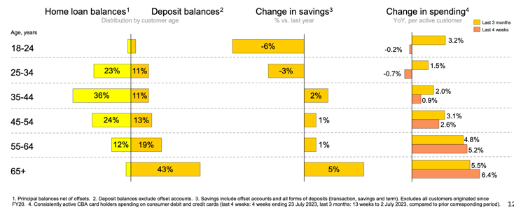
Well positioned Consumers
Struggling Consumers
We've divided the chart into two sections using a black dashed line that runs horizontally across it. As highlighted in yellow, the majority of CBA’s home loan customers are aged between 18 and 54 years. Furthermore, these customers tend to have the least amount of savings. Notably, their spending rate has decreased significantly in the past four weeks, as indicated by the orange highlight.
Contrastingly, the well-heeled customers of the bank are above 55 years of age with negligible to no loans and most of their banking is in the savings & deposits. These older age groups of consumers are the beneficiaries of higher interest rates on their deposits. As evident from the chart, this age group continues to exhibit strong spending growth, even as recently as the past four weeks.
It's possible that seniors are not only splurging on themselves but also covering some expenses for their children and grandchildren. This might be occurring because property values and share prices have generally remained stable, thereby preserving the net wealth and confidence of seniors. If seniors are bearing the expenses of younger family members, we don't view this as sustainable. It could prolong the need to maintain high interest rates, and eventually, the goodwill of seniors will run out.
#...Meanwhile interest rates continue to rise…
The chart below displays the interest rate at which the Australian government borrows money. This rate largely determines most other long-term interest rates in the economy for households and businesses. In August, this rate has been trading both aggressively and persistently, as though it is aiming to reach new highs. Even at its current levels, it suggests that companies with high debt levels may face increasing interest payments in the upcoming periods. This will reduce their earnings, assuming all other factors remain constant
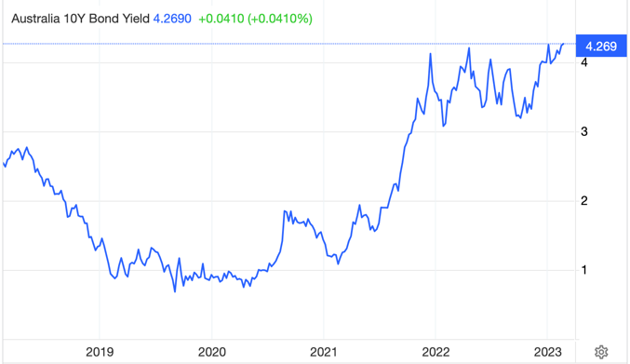
Figure 2: Interest rates remain high and pushing on the ceiling

#...Remain defensively positioned to growth
We maintain our view that investors should remain defensively positioned towards growth. We prefer high-quality stocks with low debt and recommend investment-grade credit funds for income.
GLOBAL MARKETS OVERVIEW
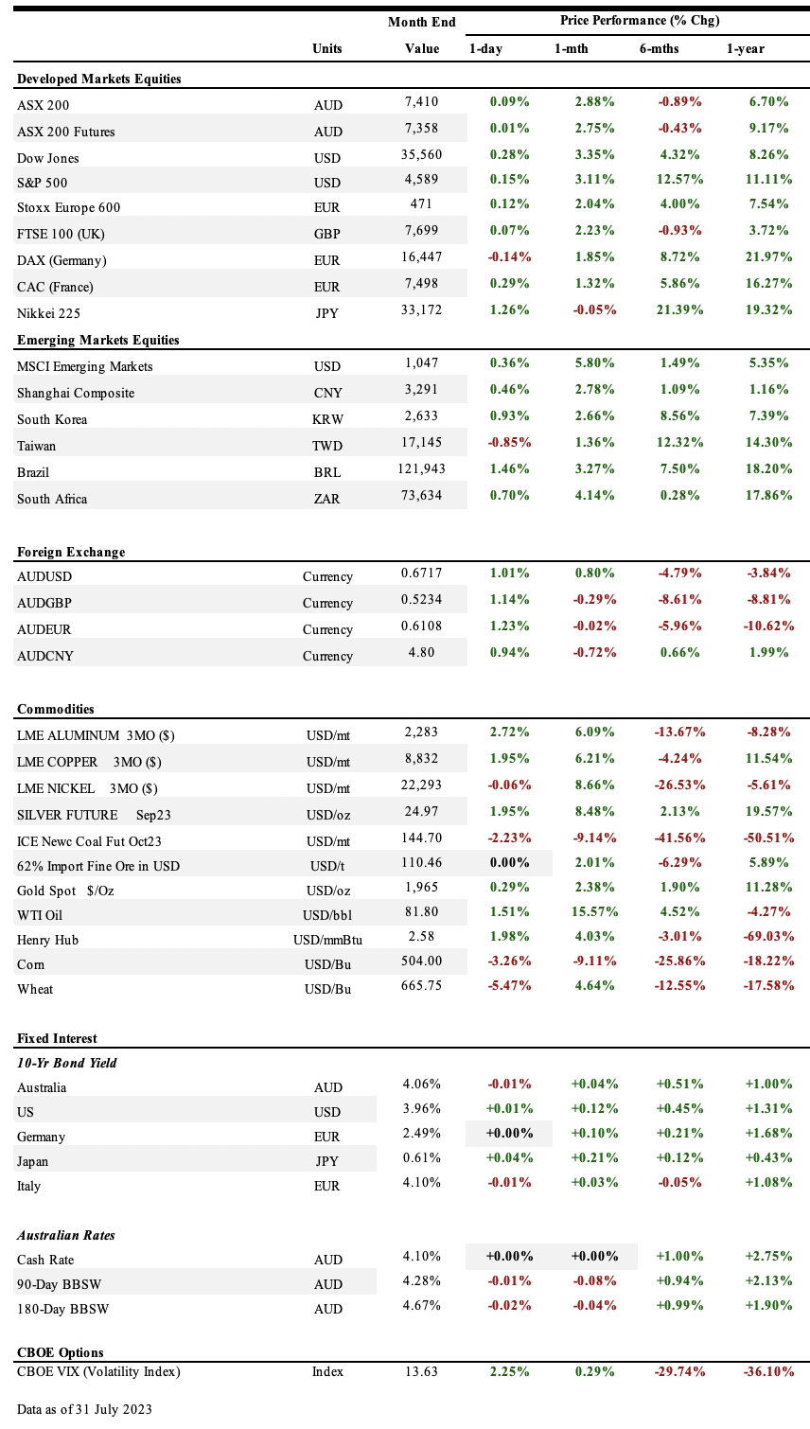

Economic News

• In Australia, The RBA kept its key interest rate unchanged at 4.1% in both July and August policy meetings, following a cooling of inflation pressures and weaker household spending, while keeping the door open to future hikes, as the bank forecast inflation easing to around 3.25% by the end of 2024 and falling back to within the target in late 2025, GDP growing at 1.75% over 2024 and unemployment rising to 4.5% by late next year.

In the second quarter of 2023, the inflation rate increased by 6% compared to the previous year, which is a slower growth than anticipated. On a quarterly basis, it went up by 0.8%. Consumer confidence saw a slight improvement in July from the previous month, but overall, people are still feeling quite pessimistic.

• The US Federal Reserve (the Fed) recently increased its interest rates to a range of 5.25% to 5.5%, marking the highest rate since 2001. The Chair, Jerome Powell, hinted at possible further hikes, but decisions will be rooted in forthcoming economic data. On a brighter note, the Fed has shifted its view on the economy, now seeing its growth as "moderate" instead of merely "modest," and has set aside concerns about an impending recession. Meanwhile, US consumer confidence soared in July, reaching a two-year peak. Many feel this is the healthiest the economy has been since March 2020, though they anticipate a 3.4% rise in prices in the upcoming year. Broadly, while the US economy has enjoyed growth since May, some regions anticipate a potential slowdown. Factory performance in July wasn't exactly stellar, marking the ninth month of decline. However, indicators like new orders and production rates are showing promise. The White House is optimistic for 2023, forecasting a 0.4% growth in the US economy. But their growth projection for 2024 has been trimmed to 1.8%. Inflation is predicted to be 3.3% in 2023 and 2.5% in 2024, while the anticipated unemployment rates are 3.8% for 2023 and 4.4% for 2024, both lower than earlier estimates. On the financial front, credit rating agency Fitch has downgraded the US's rating due to concerns about debt management and other fiscal challenges, though they believe the outlook remains stable. This decision has drawn criticism from US Treasury Secretary, Janet Yellen, who labelled it as "arbitrary" and "outdated."

• In China – Economic growth slowed down in the second quarter of 2023. The GDP rose by 6.3% compared to the previous year and only 0.8% from the previous quarter. The slowdown became even more evident in July: manufacturing decreased, the services sector weakened, and home sales dropped by a significant 33.1%, marking the largest decline in a year.

• In Europe - The European Central Bank (ECB) has increased interest rates to 3.75%. While they haven't made a clear decision about the next meeting, they've given investors some reassurance. They've hinted that they're close to concluding their phase of increasing interest rates. This comes as ECB President, Christine Lagarde, shared that the immediate economic prospects for the Eurozone aren't looking great, mainly due to a drop in local demand.

On the bright side, the economy of the Euro area began growing again in the second quarter of 2023. The GDP went up by 0.3% compared to the previous quarter and by 0.6% year-over-year. This comes after a period of decline and then stagnation.

However, inflation is still a concern. In July, the Consumer Price Index (CPI) rose by 5.3% compared to the previous year. Interestingly, the core-CPI, which doesn't include volatile items like food and energy, was even higher at 5.5%. This is the first time since 2021 that the core rate has surpassed the general rate.

Lastly, the private-sector economy in the Euro area had a rough July. It declined more than expected, hitting its lowest since November. Indicators such as order inflows and output expectations suggest that this downturn might intensify in the near future.

• In commodities - Commodities have seen some significant changes recently. For instance, the price of WTI oil increased by 15.6% over the past month, reaching US$81.8 per barrel. This rise comes as the Energy Information Administration (EIA) predicts that in 2023, global oil consumption will surpass production. Contributing to this scenario, both the OPEC+ alliance and other oil producers are expected to slightly reduce their output, bringing the total global oil supply to about 101.1 million barrels a day, which is just a bit less than the anticipated demand.

• In Politics - Fears of a China-Taiwan conflict grew as Chinese warplanes made their largest incursion into Taiwan in 3 months. Following this, President Xi Jinping urged increased military drills in the Taiwan Strait. In response, the U.S. announced a $345m military aid package for Taiwan.

THE LONG READ

Unravelling the Secrets of Successful Investing
Finding enduring success in anything in life requires a set of good habits (process), necessary skills, and a winning mindset (emotional intelligence). This also applies to being a successful investor.
This month’s article is inspired by a comment sent to us from an investor, who shared his view that finance skill is but a minor part of what it takes to be a good investor. Our response is that it really depends on how you are investing and what you are investing in. Certain types of investing will require you to have negligible or basic level of knowledge of finance while in other cases you will need to be fully across the financial statements of your invested company, for in it will lie the opportunities and the material (existential) risks.

When finance knowledge is not important
You may have heard of the term ‘Top-Down’ style of investing. Here, you require one key skill and that is reading, comprehension, and synthesising (or is that three?) of mainly non-financial information. The core of this style of investing requires you to read like a champion! Read books on a range of topics in non-fiction categories including history, economics, politics, psychology, business, biographies, personal development and so on. Develop your personal reference library. Read daily newspapers from across the globe. Subscribe to investment magazines. Keep on top of the economic indicators.
Behind your reading has to be a purpose, you as an investor must have the thirst to find answers to the most basic question; “What is really going on around you and why?”
Get behind it or under the hood to find answers and patterns. Write notes (could be a journal) about the topics you are reading to test your comprehension of the issues, arguments, and evidence on hand. Once you have stuck to this process of reading, comprehension, and synthesising information for a while, watch it then come together like magic and the ultimate fruits of your labour will be clarity. This clarity leads to confidence in investing and the hyperbolic short-term news will not unnerve you from your investing path.
Being widely read is mandatory for anyone who is embarking on an active investment journey. You need genuine interest, time, and discipline for reading. You need to be honest with yourself if this is the commitment you are willing to make for active investing, if you cut corners in this process then you are speculating not investing.
By following the above process, you are able to absorb the machinations of the world around you, you start to connect the dots (call it the mosaic theory) and observe the patterns of current and emerging consumption. You will be naturally guided to the sectors that will underpin the growing consumption patterns of goods and services, you will then find ETFs and credible active fund managers allocating capital to companies set to benefit from the identified consumption patterns and just sit back with patience for the returns will come, eventually.
In top-down investing you don’t invest directly in individual companies, you are one-step removed from this by investing in ETFs and funds. You just need to make sure that you have done your homework in understanding the consumption patterns, make sure you understand the effect of macro variables on these consumption patterns on a shorter-term and a long-term basis. So far so easy!

From here the process of top-down investing becomes trickier as the list of macro variables affecting consumption patterns is extensive. Broadly speaking, top-down investors need a firm handle on government policies supporting certain sectors while putting other sectors to permanent rest (e.g. ESG transition policies). Understand the factors driving inflation on the supply and demand side. Understand the technological advancements going on right now and how they can lead to complete restructuring of societies. For example, think internet and smart phones and how they have changed the world around us over the past two decades.
If that doesn’t dial up your attention then think about the invention of internal combustion engine in the 18th century, which led to the invention of petrol as a fuel source for these engines in the late 19th century, then came the mass production of automobiles in the early 20th century which inevitably led to the innovation of labyrinthine network of roads & highways that made possible the design of modern cities and allowed for mass mobility of humans at a scale yet to be surpassed. This made possible daily movement of freight & labour to wherever it is required across cities.
This fundamentally and dramatically reshaped societies and economies as we observe today. Consumption patterns emerged and along with them came amazing investment opportunities. Think global consumer goods companies like Coca Cola would have struggled to distribute at scale and speed on a horse cart if it hadn’t been for the delivery trucks on roads and highways. Similarly, Toyota motor company would not have existed at all if it hadn’t been for the chain of innovation discussed above, and we would have been deprived of the quality control & efficient production methods such as just-in-time (kanban) manufacturing practices that spread globally.

When finance knowledge is important
There is a second style of investing called bottom-up investing. Here you are investing in the equity and debt of listed companies directly, without the middlemen like ETFs and fund managers. This is where you do need to be across the financial and accounting jargon to a large extent. It can be working knowledge of accounting and finance, so you don’t need to be a CFA or an accountant but you certainly need to be able to read and understand how revenues are being generated from volumes sold and prices charged. You need to be able to find out if a company is recognizing revenue before it is fully earned or before the product or service is delivered to customers. You need to be able to strip out non-recurring revenue when valuing companies. This can inflate current revenue figures and overstate growth and push up share prices. In other instances, companies can acquire other companies which can lead to an immediate increase in revenue due to consolidated financials, making it seem like the company’s organic growth is higher than it actually is.
On the cost side of a company, it may have significant levels of debt borrowed at low fixed interest rates. If interest rates rise, the company might not generate enough revenue to cover the increased cost of debt, leading to a downgrade in its credit rating and making refinancing even more challenging. Such a situation could result in highly dilutive equity raisings, which would erode the interests of existing shareholders, or force the company into a fire sale of its otherwise robust assets. This is precisely what transpired during the Global Financial Crisis in 2008 with well-operated companies. These firms had highly leveraged balance sheets and were unable to sustain their hefty debt loads when faced with higher interest rates during periods of credit market disruption.

Unless you scrutinize the numbers, you risk severe financial repercussions, similar to the fates of once-renowned companies like Babcock & Brown vehicles, Centro Property Group, and even Goodman Group (the largest listed REIT). Goodman Group nearly decimated its equity holders during the GFC in 2008 due to its massive debt burden. It was essentially rescued from the brink of financial collapse by new investors, which included a foreign sovereign fund. These astute investors subsequently profited significantly by rejuvenating the business. They were fully aware of the financial leverage they were engaging in when they recapitalized Goodman Group's balance sheet at the opportune moment. The rest, as they say, is history!

In conclusion, the top-down style of investing has a certain allure. Not only can this approach potentially increase your wealth, but it can also enhance your knowledge, making you an engaging conversationalist in social settings. While some might find joy in analyzing financial statements, it's essential to also understand top-down issues to truly profit. That means twice the effort!
Here is the book we are reading right now:
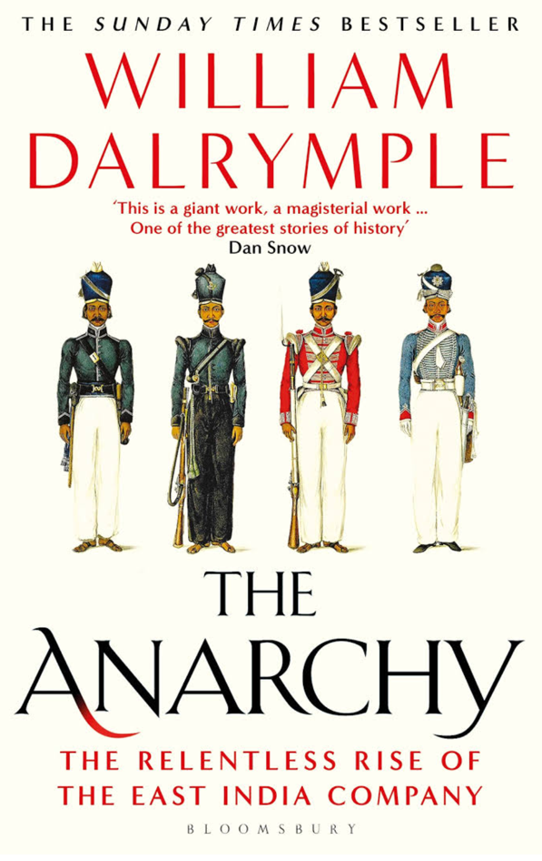
In the race for global economic supremacy, India is fast-tracking its journey, potentially outpacing even China in the coming decades. For investors, understanding India's intricate tapestry of history, politics, and economy is crucial. One of our current reads that is providing an enlightening perspective is this engrossing book that masterfully intertwines India's economic and political history over the past 600 years with the rise of the world's first corporate behemoth: The East India Company. More than just a recounting of events, this book delves deep, offering readers a captivating tale that is hard to put down. For anyone keen on grasping the evolution of the Indian state, this tome comes highly recommended by us. Dive in and enrich your understanding of a nation on the cusp of becoming a global economic leader.

For enquiries:
- Email
- Phone (02) xxxxx (within Australia), or
- Write to:
xxxxx

IMPORTANT DISCLAIMER – Please read carefully
This newsletter is copyright and is for the clients of xxxxxx. The reproduction of any part of the letter, for any purpose, is not permitted. The view expressed in the newsletter are for general information purposes only and are not meant to be taken as personal financial advice.
Goods

