Investment Newsletter – September 2023
Slowdown ahead – invest for income

Welcome to the September investment letter.

The Australian share market is down roughly -1% since our last monthly letter in mid-August, four weeks ago. There was a market rally of circa +3% in the first two weeks, followed by a sell-off of -5% peak-to-trough over the subsequent two weeks. The market volatility has also risen accordingly.

What is going on, you might ask?

Two things have happened this month.

The central banks have indicated that interest rates will likely remain higher for a longer period, extending until late 2025. The primary reason for this outlook is the oil price. It has been driving inflation higher over the past two years and has spiked again by +14% over the month.

Figure 1: Crude Oil (USD/bbl)
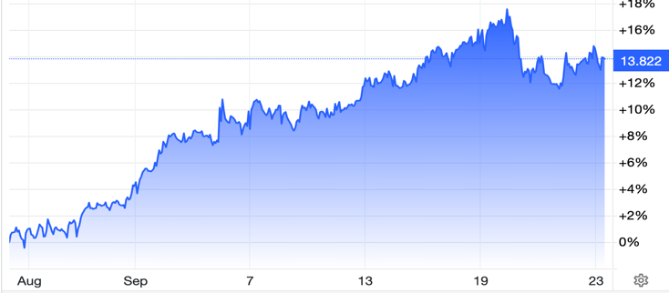
Source: tradingeconomics.com

As we have said in the past, oil producing countries (OPEC) continue to cut supply to prop up the oil price for two reasons:

1) Harvesting oil revenues ahead of permanent shift to renewables - Oil producers are reading the same tea leaves as the rest of us, forecasting the inevitable transition from the world’s dependence on fossil fuels to renewable energy. Thus, there is little incentive for OPEC countries to drive down oil prices in the near term and provide disinflationary relief. In that context, it is perfectly rational economic behaviour for OPEC countries to continue cutting oil production, push up oil prices, and harvest as much oil revenue as possible.

2) Oil price as a political tool - OPEC+ is a group that is perceived to sympathize with Russia. Market conjecture suggests that this group might attempt to sway the outcome of Trump’s potential re-election in the US in November 2024. Given this, it's plausible to assume that OPEC+ could leverage oil price and inflation to cast the current US administration in an unfavourable light regarding their management of the economy ahead of the upcoming election.

The above two reasons will likely keep inflation higher for longer.

What are the consequences of persistent inflation?

The first consequence of persistent inflation is that interest rates rise. That much we know from a lived experience of the past two years. However, the increase in bond yields over the past four weeks, as shown below, is clearly suggesting that it expects interest rates in the economy to rise even further, by an additional 0.25%. We are sure if you were to ask your bank for a quote on a 1-year or 2-year fixed interest rate, that rate would have gone up by circa 0.25% over the past month.

Figure 2: Australia 10-year bond yield (interest rate)
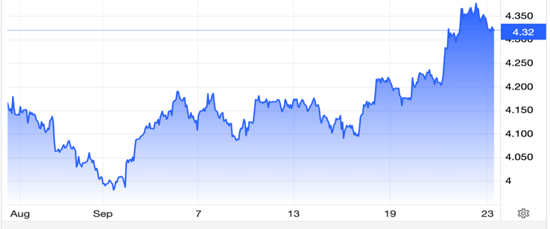
Source: tradingeconomics.com

The second consequence of persistent inflation and higher interest rates is that they eventually cause real disposable income to fall (in the absence of productivity growth), leading people to cut back on consumption. Less disposable income means less consumption. It’s just a matter of time!

Two of the greatest economic thinkers of the past century, John Maynard Keynes and Milton Friedman, had their differences. However, they broadly agreed on one thing: consumption behaviours are directly linked to people’s income. When income rises, consumption and savings both increase. Conversely, when income falls, people initially maintain their consumption behaviours, hoping that the short-term spike in the cost of living is transitory and that their income will eventually rebound. In the interim, rather than reducing consumption, people draw from their savings and might even liquidate some investments to sustain their spending. However, if the cost of living and interest rates persistently remain high, and wages don't keep pace with inflation — a situation that mirrors current events — consumers eventually reduce their consumption to align with the new economic reality. By this point, savings are depleted, unemployment begins to rise, and continues to do so.

Figure 3: In Australia personal savings rate is declining
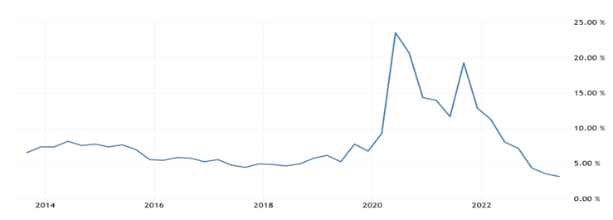
Source: tradingeconomics.com

In essence, we are suggesting that 2024 is likely to be a slow year for the economy and the share market is unlikely to deliver much growth. Income via dividends & credit securities is where you want to be investing. Growth is to be found in offshore equities, which is an exciting topic we are keen to discuss in next month’s letter. Please take the time to read the back article of this issue which sets the context for next month’s letter.

GLOBAL MARKETS OVERVIEW
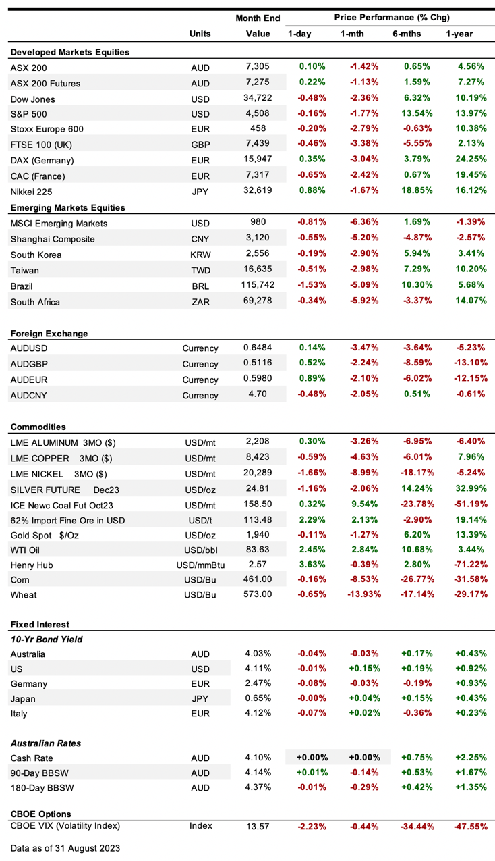

Economic News

• Australia's central bank, the RBA, has decided to keep its main interest rate at 4.1%. The bank's leader, Philip Lowe, said that they might need to increase rates in the future. This is because the economy is not growing as fast as they thought it would. They now expect the economy to grow only 1% in 2023, which is a bit lower than their previous prediction.

The cost of living is going up, and so are interest rates, which is making people spend less. However, the bank thinks the economy will grow by 1.75% in 2024 and 2.25% in 2025. As for inflation, the bank expects it to be 4.25% in 2023, 3.25% in 2024, and 2.75% in 2025. They aim to bring it back to their target range of 2-3% by the end of 2025. This means that interest rates might stay high for a while to control inflation.

From April to June 2023, companies invested more money than people thought they would, with a 2.8% increase from the last three months. At the same time, people's pay checks got a little bigger, but not as quickly as the cost of living went up. This means it's unlikely that higher pay will make things more expensive in a never-ending cycle. However, in August, people got even more worried about how the economy is doing, even though they think the cost of things will go up a bit less in the next year.

• In US - The people at the Federal Reserve, who help manage the country's money, are worried that prices will keep rising. They're thinking about making it more expensive to borrow money to slow this down. The economy didn't grow as much as first thought from April to June 2023. This was mainly because businesses didn't spend as much as expected, even though people did spend more. In August, more jobs were created, but the number of people without jobs also went up a bit because more people started looking for work. Also, paychecks didn't grow much. People are feeling less hopeful about the economy compared to July, especially because they think things like gas will get more expensive. But there's a bit of good news: factories are doing better than before, making more stuff and hiring more people.

• In China – Factories in China did a little better in August, getting more new orders for stuff. But other businesses like restaurants and stores didn't do so well, hitting their lowest performance since last December. Also, the money coming into China from other countries dropped a lot between April and June 2023, reaching the lowest level in 25 years. To help improve the economy, China's central bank made it cheaper to borrow money. They lowered the interest rate for one-year loans and also cut another rate that affects short-term borrowing. This is meant to encourage people to spend and invest more.

• In Europe - businesses in the euro area struggled more in August. For the first time since the end of 2022, services like restaurants and stores didn't do well. Factories also continued to have a hard time. Meanwhile, the cost of things stopped going down and actually went up by 5.3% compared to last year.

• In India the Reserve Bank of India (RBI) decided not to change its main interest rate, keeping it at 6.50%. At the same time, they told banks to hold back 10% of the new money they got from customers between May 19 and July 28. This is because the RBI thinks prices will go up a bit more than they first thought, mainly because food is getting more expensive. Meanwhile, the economy grew by 7.8% from April to June 2023. This growth was mostly because of businesses like restaurants and stores doing well, and factories also did a bit better, even though borrowing money is still pretty expensive.

GLobal Markets

• US markets were lower in the month, with the Dow Jones down -2.4% and S&P500 down -1.8%, Fitch downgraded the US credit rating to AA+ from AAA, citing "repeated debt limit standoffs," expected fiscal deterioration over the next three years and little progress in tackling rising social security and Medicare costs, followed by both Moody’s Investors Service and S&P Global Ratings downgrading some small and midsize American banks.

• European markets were weak with the Stoxx Europe 600 Index down -2.8% and German DAX down -3.1%, after ECB President Christine Lagarde warned the bank will set borrowing costs as high as needed and leave them there for as long as it takes to bring inflation back to its goal.

• ASX performance. The ASX200 declined -1.4%.

THE LONG READ

Tech innovations are about to experience a super-confluence
The world that we live in is set to undergo significant changes in the next decade and beyond.
The root cause of this imminent change is that the individual technological advancements of the past decades are set to combine forces and thrust forward change at a speed that we have not experienced in the past. This rate of change of innovation will not only accelerate at rapid speed this decade but also completely disrupt and rewrite industries in the coming decades. From architecture and artistry to aviation and accounting, dozens of industries will soon be transformed.
Before offer some examples of change coming your way and how as investors you will have a smorgasbord of opportunities to create wealth at a magnitude that has never been done before and it will happen fast - invention of internet and industries/jobs/wealth it has created can be a good benchmark for the possibilities ahead. Let us first discuss the driver of this change, it’s called convergence.
You may remember Gordon Moore’s Law, who as the founder of Intel (the company) observed back in 1965 that the number of transistors on a circuit board doubled every eighteen months, which meant that computers became twice as powerful every 1.5 years for the same cost. Essentially, over the past sixty years, computers have continuously become more powerful to this day while costs have fallen dramatically as well. Today, you have a smartphone in your hand which is a thousand times smaller than Moore’s computer, and a thousand times cheaper, and million times more powerful than a super computer from the 1970s.
The exponential growth in computing power, as exemplified by Moore's Law, extends beyond just computing power itself. Moore's Law, which involves continuous improvements in performance and cost-effectiveness, applies to a wide range of technologies, resulting in advancements and breakthroughs across diverse domains.
Ray Kurzweil, director of engineering at Google, in the 1990s discovered this broader application of Moore’s law and named it the “Law of Accelerating Returns”. Essentially, the law says that we use our new computers to design even faster new computers and this creates a positive feedback loop.
To name a few technologies that are currently undergoing fast innovation feedback loops include, but not limited to, quantum computers, artificial intelligence, robotics, nanotechnology, biotechnology, material science, networks, sensors, 3-D printing, augmented reality, virtual reality, blockchain, and more.
We are not sure if you remember sinusoidal wave chart from your HSC maths, great if you do as the following example will help you visualise the impact of convergence we are about to describe.
So, take each individual category of technology such as computing power or AI which have been experiencing pulses (or waves) of new improvements (innovation) occurring over the past few decades. Imagine if you map these past improvements as sinusoidal wave, where each pulse denotes a new improvement. What the convergence theory suggests is that these independent waves of tech innovations are beginning to converge with each other to form future waves with combined pulses of innovation that will lead to significantly amplified and tsunami-sized innovations.
As an example, in healthcare, quantum computers will be able to process infinitely producing live data sets being fed from ubiquitous bio-sensors connected over the +5G spectrum. The quantum computers will use AI to analyse the information to find new drugs, monitor, and prevent disease. Imagine the positive impact to the quality of health and longevity from this advancement!
Let us contrast the term disruption with convergence at this point to give you further context on how significant the impact of converging technologies will be. While disruption and convergence both lead to change, their impact is vastly different in magnitude.
Solitary innovations cause disruptions which usually result in singular new markets, new products, or new services. Take Netflix as an example which wiped out the movie rental outlets, or the smartphones which took away the need for video camcorders and hand-held cameras.
However, with convergence you not only see old markets, products, services get wiped out but also their support structures also go. An example of this would be, as streaming platforms and digital media gain popularity, traditional media outlets like newspapers, magazines, and even some TV channels face challenges. The support structures, such as printing presses, distribution networks, and TV broadcasting equipment, can become obsolete. That is, whole supply chains get wiped out. The point is that convergence’s impact on change is much deeper and pervasive.
Turning to what investment possibilities you could exploit based on the above information.
Our view is that if you openly embrace the above argument for change then you will be able to maintain heightened alertness to the investment opportunities as they present themselves.
With early stage technologies like quantum computing, we suggest turning to ETFs rather than investing in a single company as the rate of failure of early stage individual businesses is high.
We espouse the view that in the short term nothing changes and in the long term everything changes. If you are investing for the next one-year time horizon in terms of the returns expectations then that is just trading the arbitrage in share prices on a short-term term basis in existing stocks. In that case, all of what we have said in this article doesn’t apply to you.
However, if you are investing for the next ten years and beyond, the long term if you will, then you might want to consider what Yale University’s Richard Foster stated; 40 percent of today’s Fortune 500 companies will be gone in ten years, replaced, for the most part, by upstarts we’ve not yet heard of.

For enquiries:
- Email
- Phone (02) xxxxx (within Australia), or
- Write to:
xxxxx

IMPORTANT DISCLAIMER – Please read carefully
This newsletter is copyright and is for the clients of xxxxxx. The reproduction of any part of the letter, for any purpose, is not permitted. The view expressed in the newsletter are for general information purposes only and are not meant to be taken as personal financial advice.
Goods

